**Chapter 2 : Analysis**

**Introduction**

In this part, I will describe about functional and non-functional. I will also represent the use case diagrams and classe diagrams in this part with the system architecture. Technical architecture like php, mySQL and other development languages and software will be described in detail too.

**Use Case Diagram**

Use case diagrams the description of the interaction between User and the element of the system. Use case diagrams show the relationship between the business cases(system) and the actor (human). Its main purpose is to show the dynamic aspects of the system. Use case diagram mainly include those elements; actor, association and the usecase. Use case diagrams are assumed as the high level systematic analysis so they are captured in the diagram when it need to analysis the requirement of the system.

**Class Diagram**

Class diagram show the dependencies between the classes and the source code. Class Diagram include three portions; class name, attribute and operation. Class diagram represent the internal the classes ,the object of the internal system and the relationship between classes. Class diagram can describe the properties and operation of the class. Class diagrams represent the static view of the system.

**Functional Requirements**

**Applicant Scope**

* Sign up in the website.
* Top-up the prepaid card
* Search for the album
* Purchase and Download

**Staff Scope**

* Check the customer’s money amount in the account
* Help the Users’ problem (FAQs)
* Save the user’s account to retrieve in daily report
* Bank Staff will update top up codes

**Report**

* Provide the weekly report for admin
* Provide Product List
* Provide Staff List
* Provide Bank Staff List
* Provide the User List

**Non-functional Requirements**

|  |  |
| --- | --- |
| List Of Requirements | Description |
| Avability | The music store should be usable by customers.  The staff should be able to response to customers. |
| Flexibility | The website should be flexible i.e, lack of errors and users’ problems |
| Performance | The website should be perform smooth. There should be less crashing and reducing speed. |
| Security | All the users’ account will be provide with passwords. Passwords will be encrypted and storeed in Database |
| Usability | The webpage should be usible on both computers and smartphones. |

**Use Case Diagram & Use Case Description**

**Overall system**

**Figure 1 : Overall of the whole system**

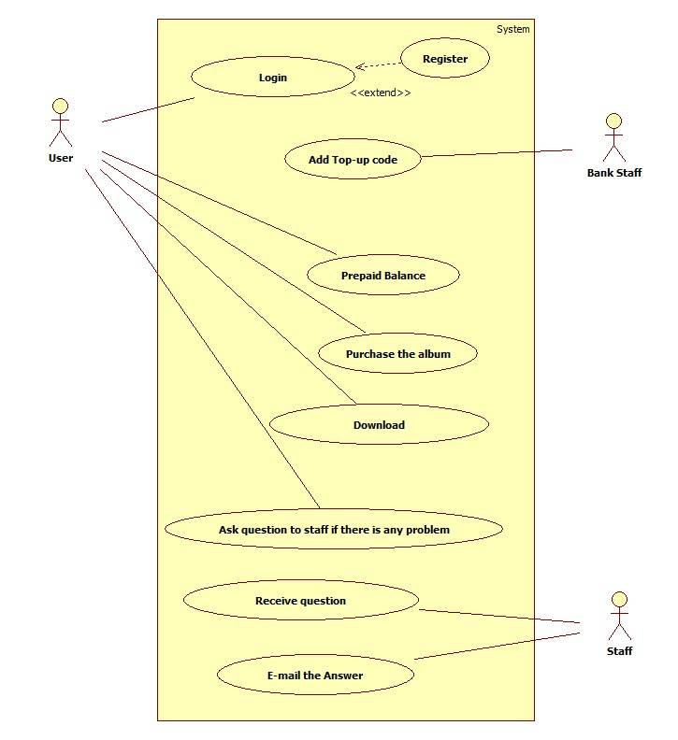

**Sign up in the website**

**Figure 2 : User register in the store**

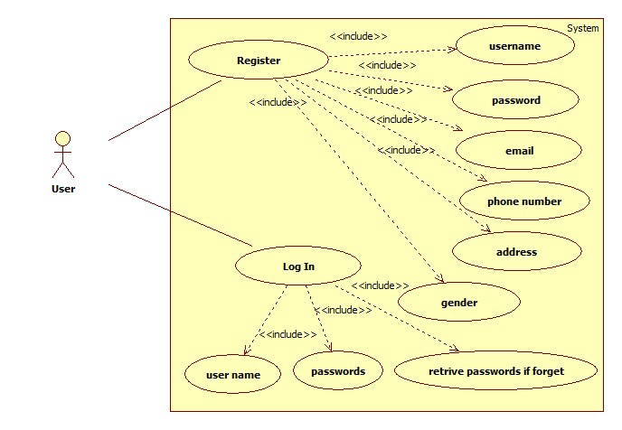

**Top-up the prepaid card**

**Figure 3 : User transfer money to his/her account**

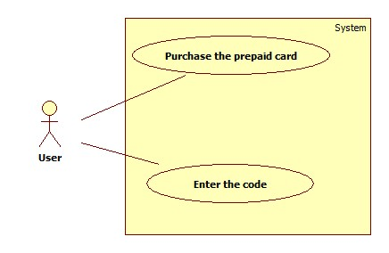

**Search for the album and purchase and Download**

**Figure 4 : User purchasing the item**

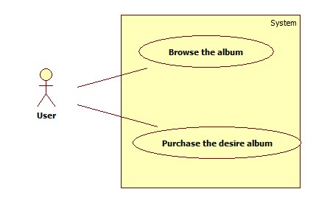

**User asking about the problem on using website**

**Figure 5 : User asking about the problem on using website**

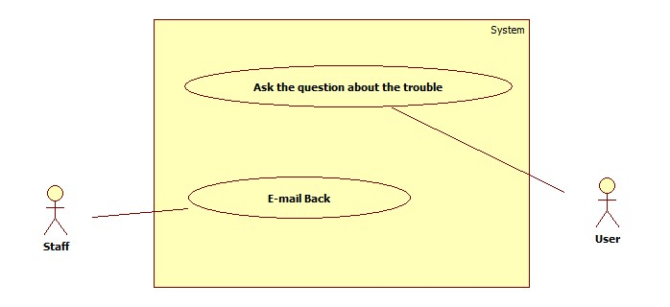

**Bank staff adding top up bills**

**Figure 6: Bank staff process**

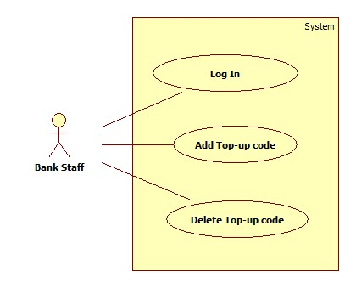

**Provide the report**

**Figure 7: Provide a report to admin**

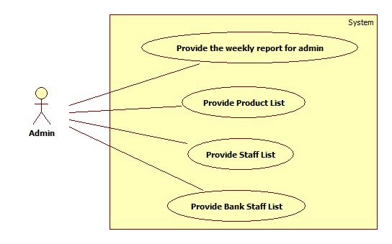

**Development Supporting Tools**

**Brackets**

Bracket is an IDE which is focus in web developments and design. It is an open source IDE. Its great point is it can perform multitasking, so you can code html and css at once. Bracket IDE is produced for Windows, Mac and Linux platforms. In Brackets IDE, you can develop programs with html, css, javascript and PHP.

**XAMPP**

XAMPP is the open source software which perform web server. It contains Apache HTTP server, MySQL and it knows the php language. XAMPP is easy to install and it supports every version of windows.

**PHP**

Php is server side programming language and it can connect with database easily. It is easy to study and good for dynamic websites. PHP can do actions such as read, write and open on the server side and able run on different OSes. PHP can send the cookies and receive cookies and can create, retrieve, update, delete data in the database. I will use PHP for sever scripting in this project

**MySQL**

MySQL is the popular database system that mainly use in web developments. MySQL performance is very high and there are many embedded applications which makes it very flexible. It can make transactions commit, rolled back and recovery. MySQL will be database language in my project.

**Initial Class Diagram**

**Figure 8 : Initial Class Diagram**

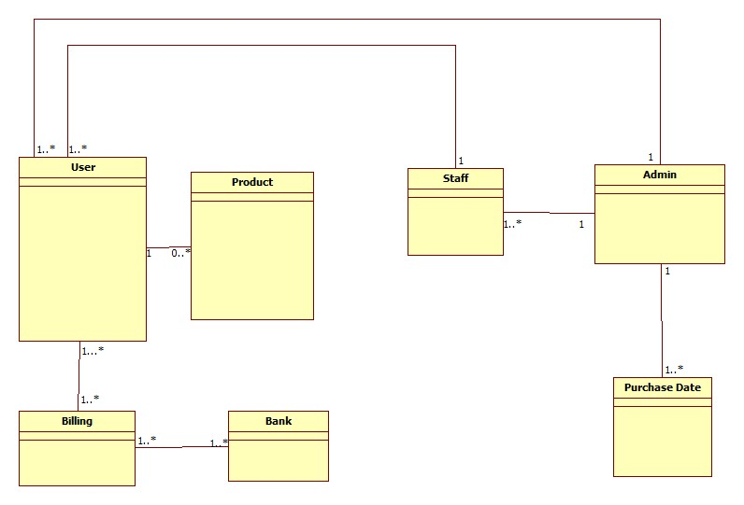

**Conslusion**

In this chapter, we have described the detail of the use case diagrams and intial class diagram. Initial class diagram help to understand overview architecture of the system. Prioritized functional and non-functional requirements are identified. We also describe about the programming languages and softwares that will be used in project.